**LAB 3**

**EXERCISE**

1. Viewing Your Processes

* Use the ps command to find the PID of your current shell (e.g., bash).
* Run the top command. While it's running, sort the processes by memory usage. What is the command of the process using the most memory?
* Exit top.

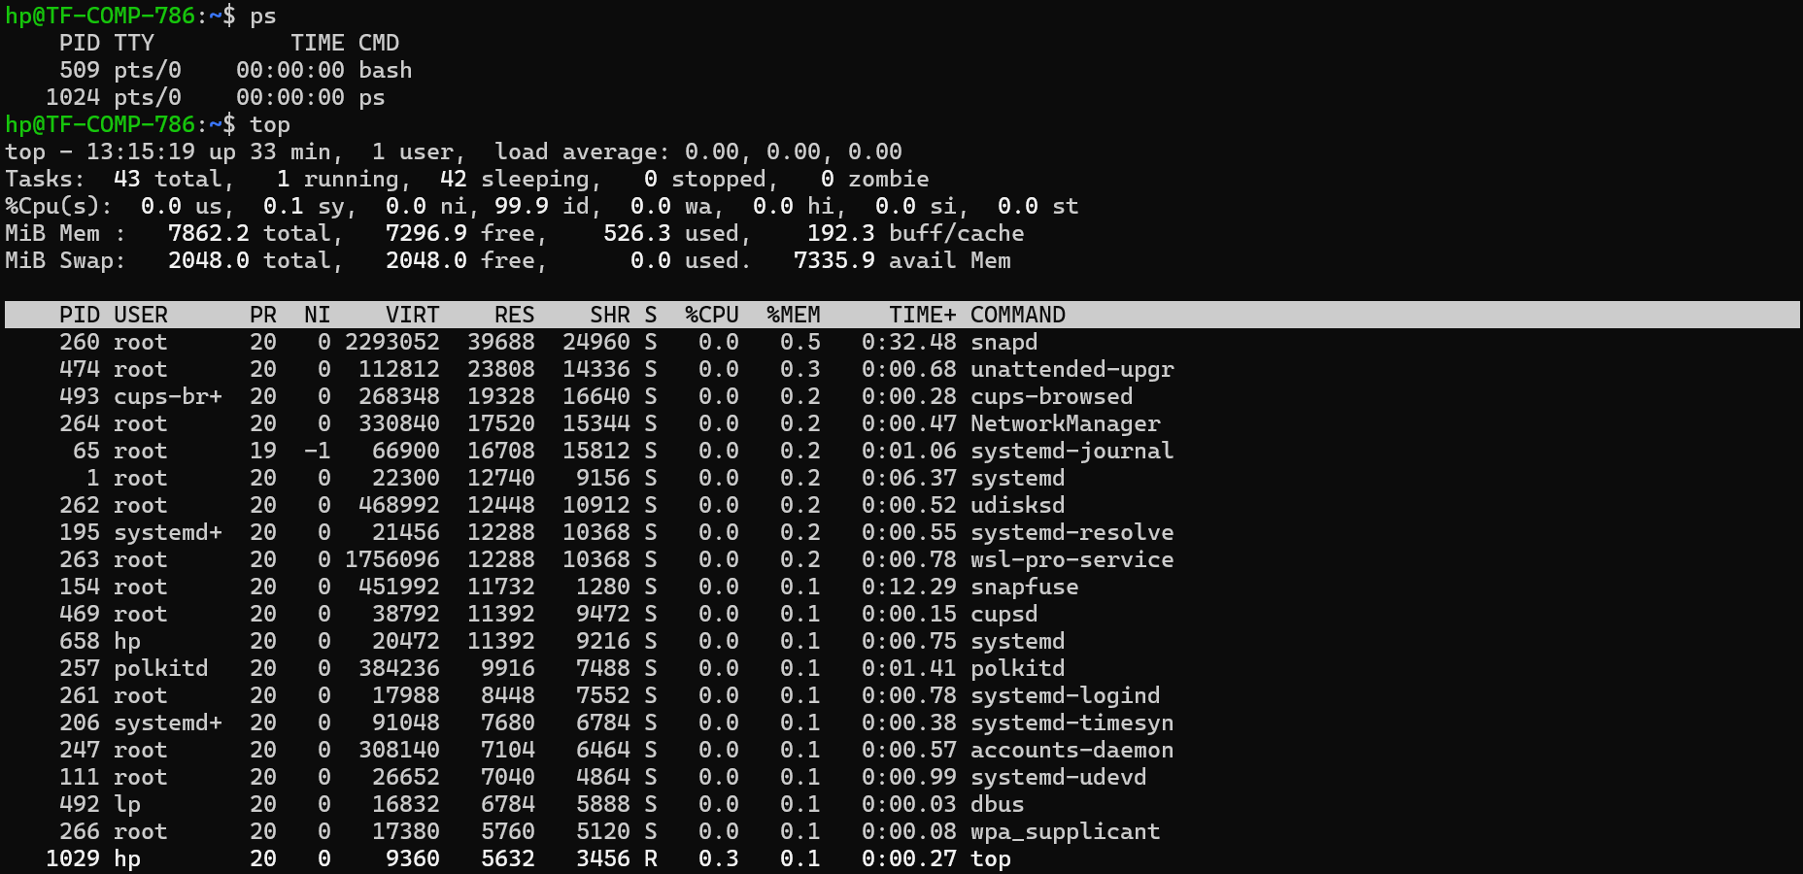

Exit top by pressing **q**.

1. Backgrounding a Process

* Run the command sleep 500 in the background.
* Use the jobs command to verify that the process is running in the background.
* Use ps aux | grep sleep to find the PID of your sleep process.

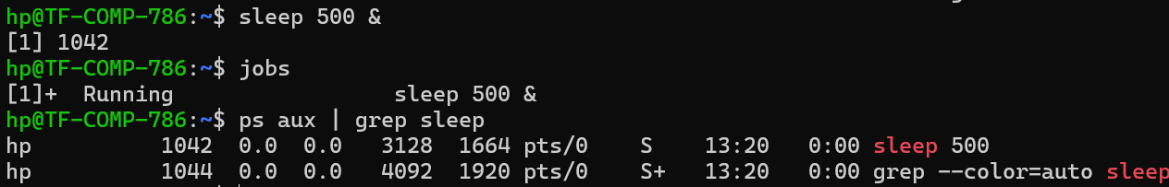

1. Job Control in Action

* Run a command that takes a long time, like find / -name "*" > /dev/null 2>&1. (This will search your whole filesystem and may produce permission errors, which we are discarding).
* After about 5 seconds, stop the process using CTRL+Z.
* Use the jobs command to see the stopped job.
* Resume the job in the background using the bg command.
* Finally, bring the job back to the foreground using the fg command.
* Terminate it once and for all with CTRL+C.

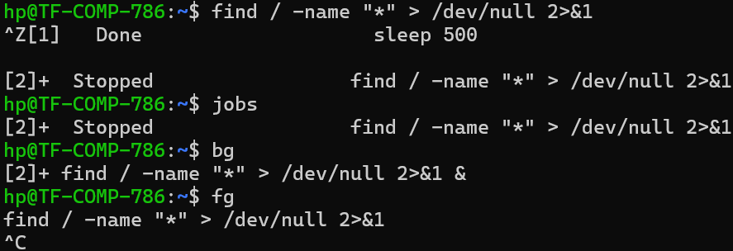

1. Terminating Processes

* Using the PID you found in step 2, terminate the sleep 500 process with the standard kill command. Verify with jobs that it is gone.
* Start another background process: sleep 600 &. This time, use the killall command with the process name to terminate it.

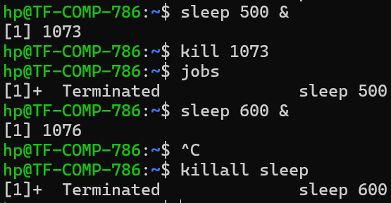

1. Conceptual Questions

* What is the purpose of the process with PID 1 (often named init or systemd)? Why should you never try to kill it?
* What is the difference between a normal kill and kill -9 ? When would you use the second one?
* What is a "zombie" process? Which command would you use to see if you have any on your system?

**Purpose of PID 1 (init or systemd):**  
It’s the **first process started by the kernel** at boot. It initializes the system and is the ancestor of all other processes. If you kill it, the system will crash (panic) because no one is left to reap zombie processes or manage services.

**Difference between kill <PID> and kill -9 <PID>:**

* kill <PID> sends **SIGTERM** (default) — asks process to exit gracefully (cleanup, save state, close files).
* kill -9 <PID> sends **SIGKILL** — forcefully kills immediately, cannot be caught or ignored.
* Use -9 only if normal kill doesn’t work.

**Zombie process:**  
A process that has **finished execution** but still has an entry in the process table because its parent hasn’t collected its exit status. You can see zombies with **ps aux | grep Z**